FABRIC ROOF: The pergola from NIHVA have aluminium frame and the fabric roof which is fully retractable canopy cover, which at the touch of a button can be extended to provide shelter, or retracted to take advantage of the good weather. The canopy oﬀers a ﬂat surface that guarantees the discharge of rain water.

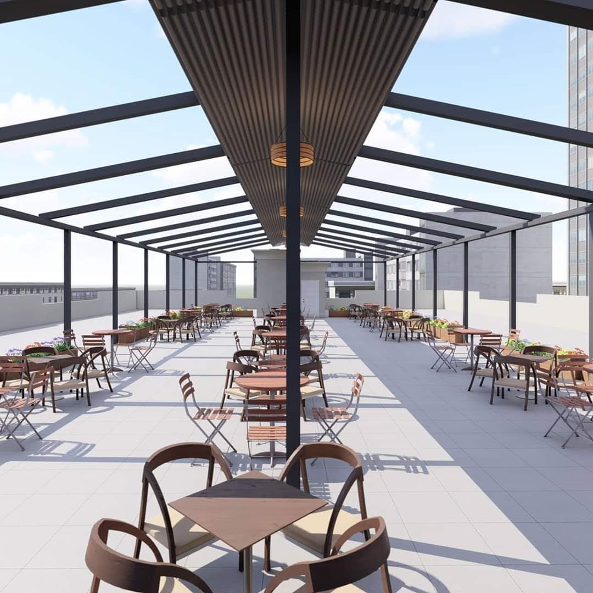
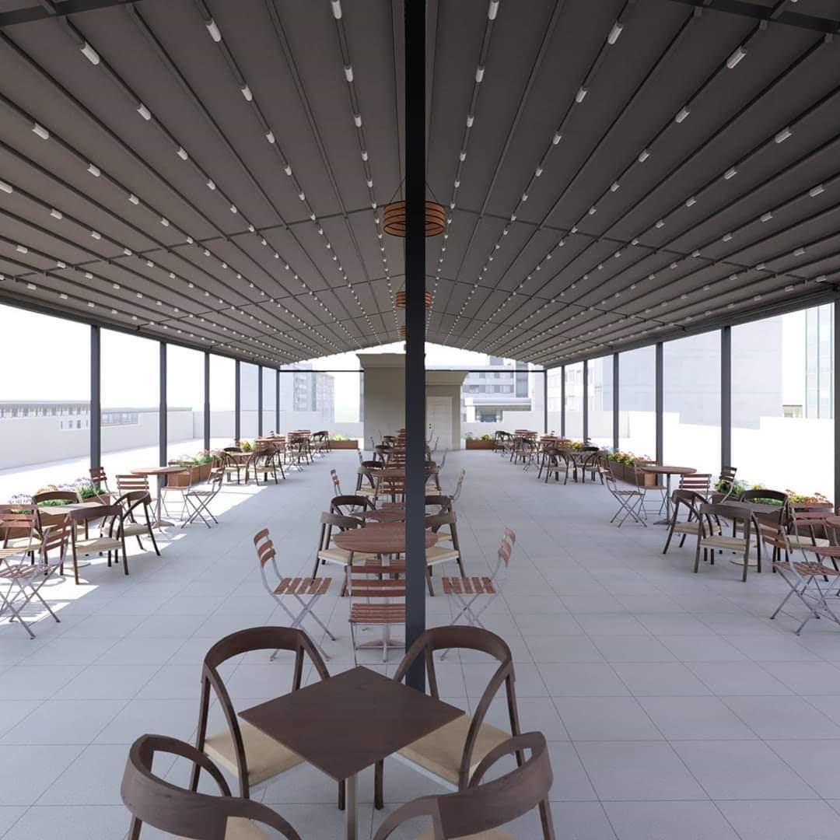

Aluminium Louver System from NIHVA is a great way to provide all year-round weather protection from the dust, dirt and rain with the option of Aluminium Louver and sides screen creating a totally enclosed area.
Available in many design options, the Aluminium Louver rotating blades which operate at the touch of a button can be closed to provide shelter, or opened fully or partially to take advantage of the good weather. The blades have interlocking system which oﬀers a ﬂat surface that guarantees the discharge of rain water, and can resist sun and wind accordingly.
Application：
◼ Private residence, villas, and other civil areas
◼ Commercial venues: hotels, restaurants, stores
◼ Garden supporting facilities engineering



